SET 11 – Product Category Analysis
Q1. Pie Chart
category <- c("Electronics","Clothing","Appliances")
sales <- c(50000,35000,40000)
pie(sales,
labels=category,
col=c("skyblue","pink","lightgreen"),
main="Sales Distribution by Product Category")
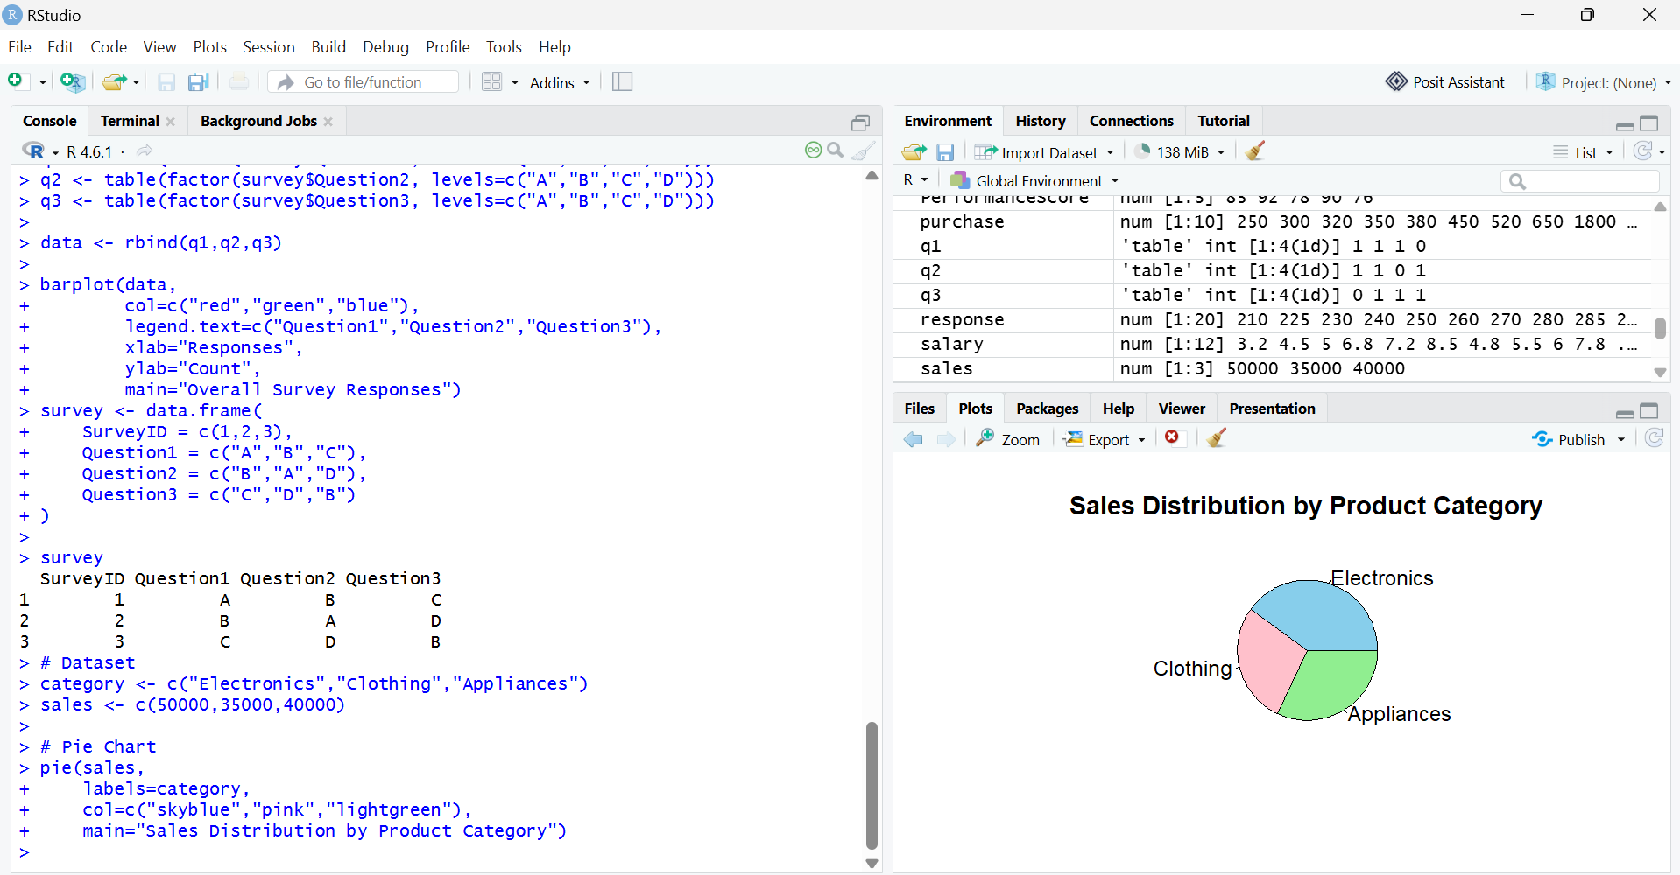

Q2. Funnel Chart
category <- c("Electronics","Clothing","Appliances")
sales <- c(50000,35000,40000)
par(mar=c(5,8,4,2))
barplot(rev(sales),
names.arg=rev(category),
horiz=TRUE,
col="steelblue",
xlab="Sales ($)",
main="Sales Conversion Funnel")
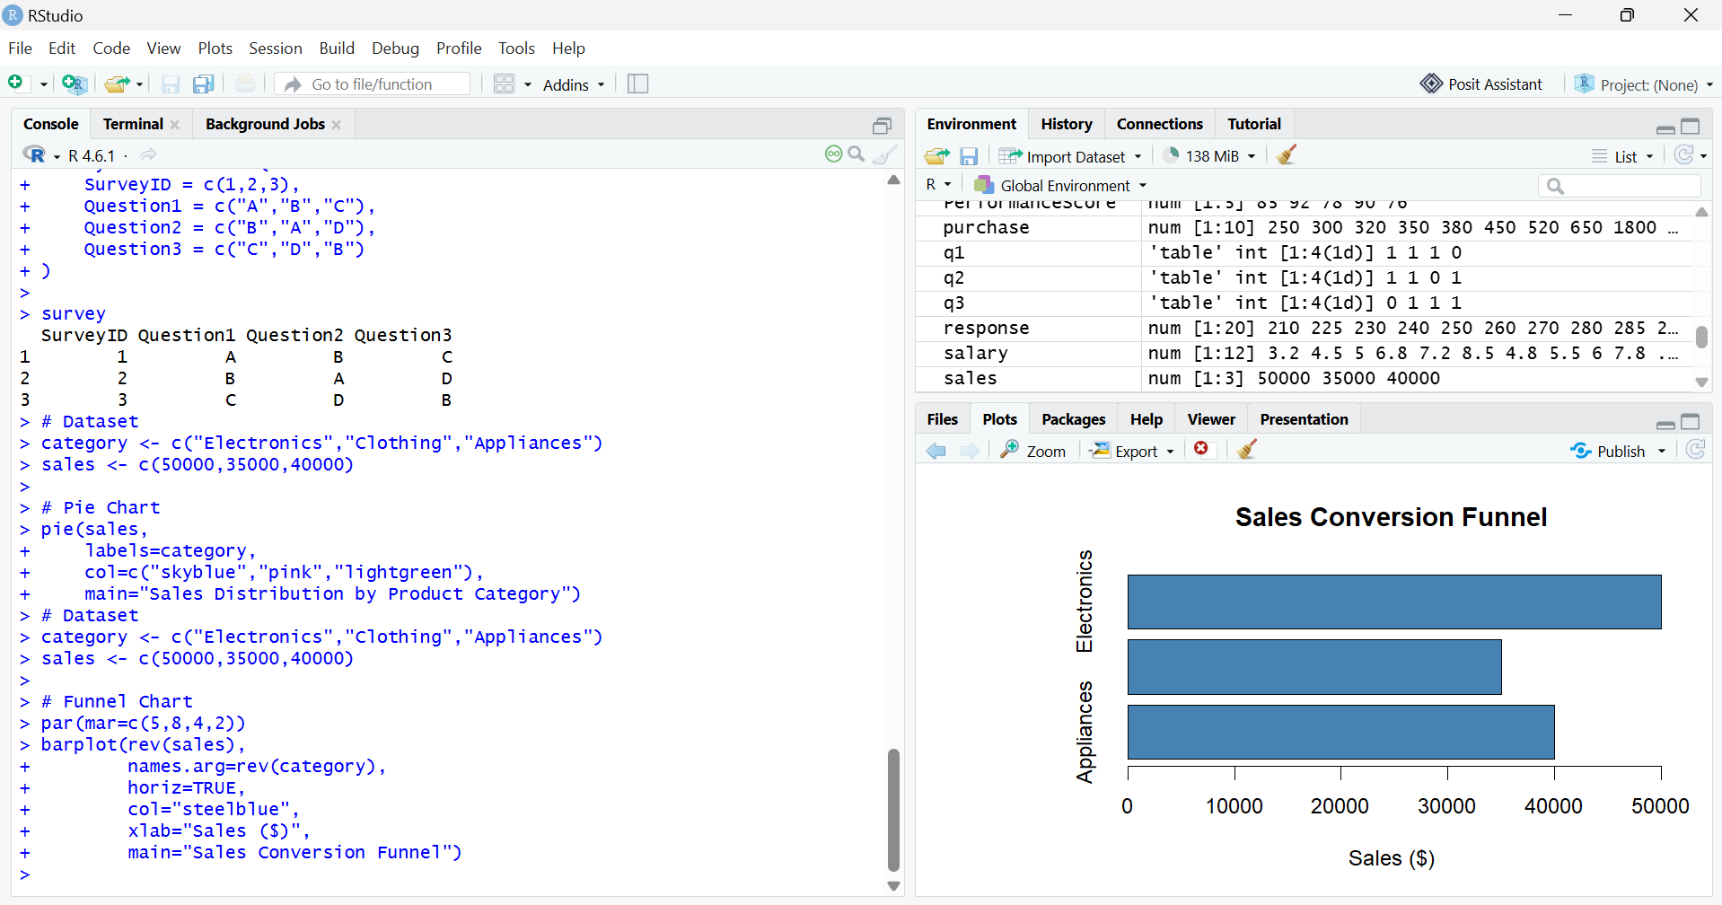

Q3. Table
product <- data.frame(
Category=c("Electronics","Clothing","Appliances"),
Sales=c(50000,35000,40000)
)
Product
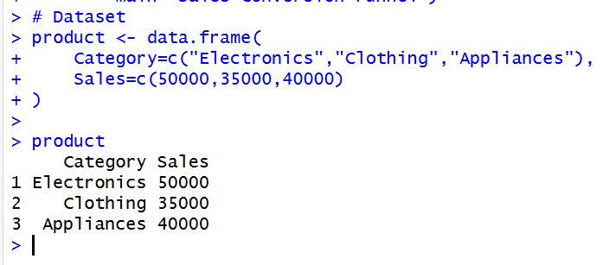

SET 12 – Website Traffic Analysis
Q1. Line Chart
traffic <- data.frame(
Date=as.Date(c("2023-01-01","2023-01-02","2023-01-03")),
PageViews=c(1500,1600,1400),
CTR=c(2.3,2.7,2.0)
)
plot(traffic$Date,
traffic$PageViews,
type="o",
pch=16,
col="blue",
xlab="Date",
ylab="Page Views",
main="Daily Page Views")
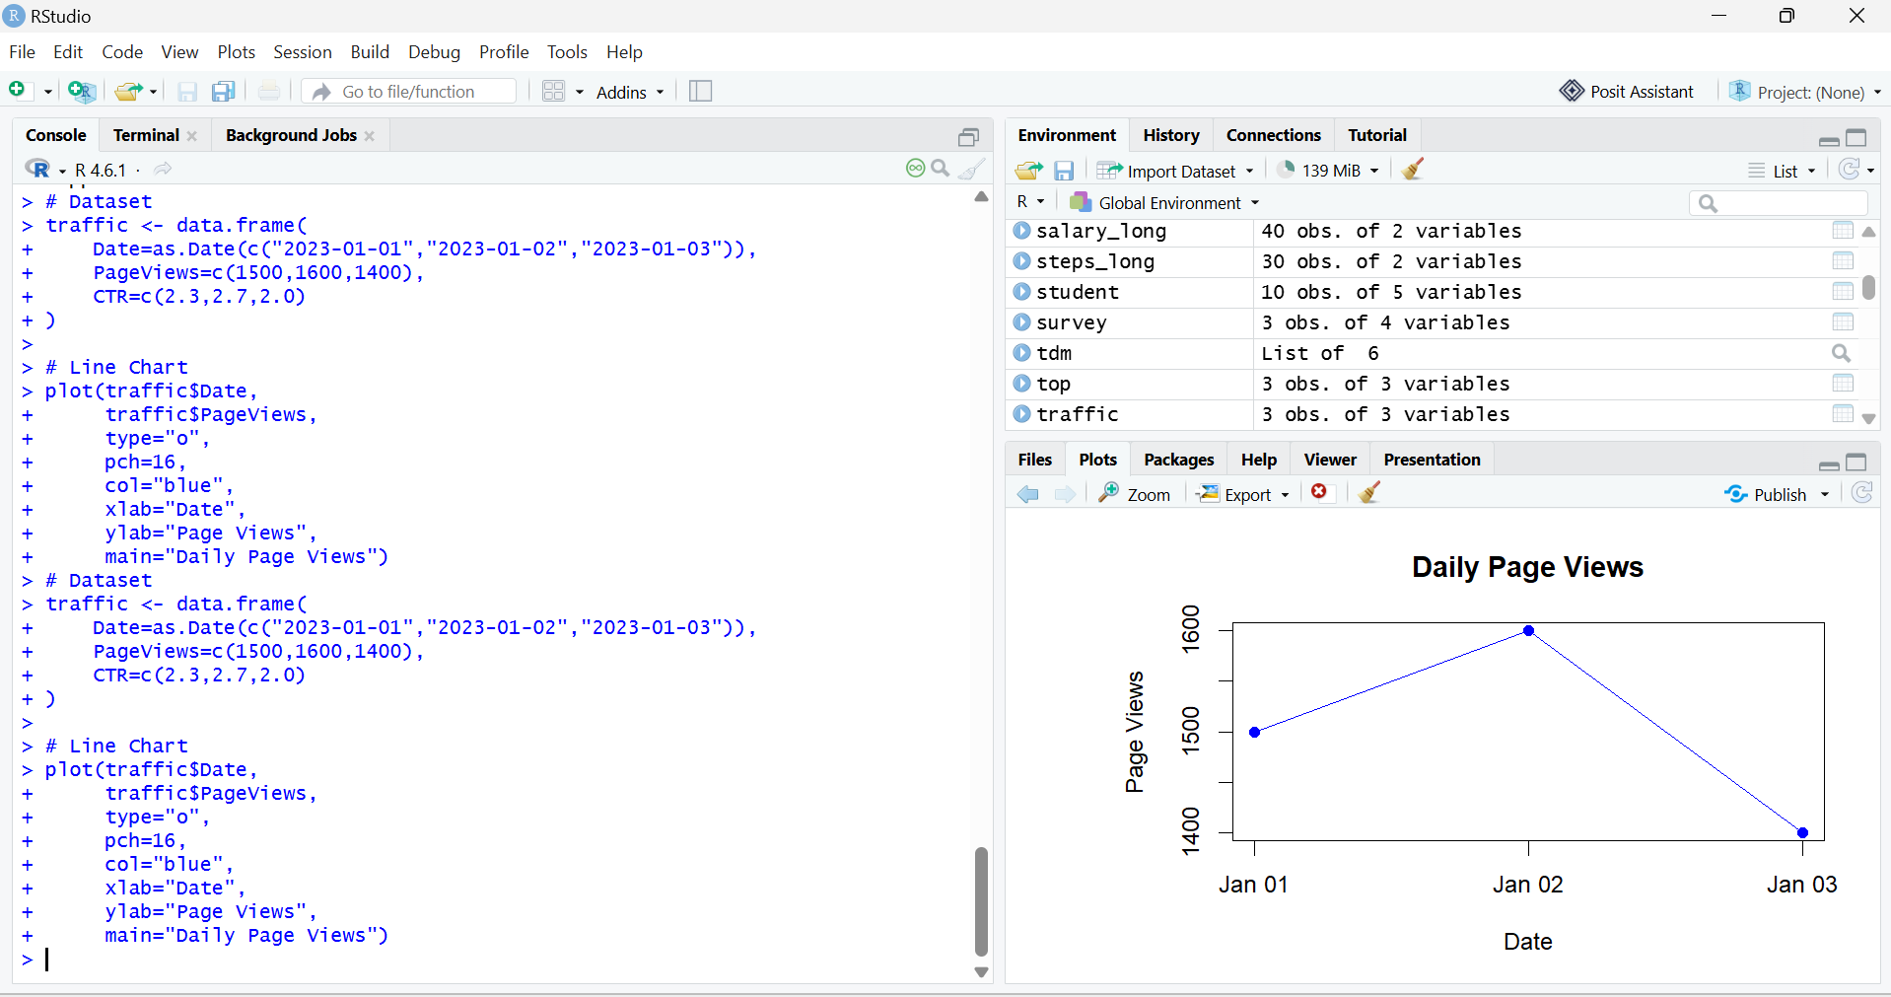

Q2. Bar Chart
traffic <- data.frame(
Date=c("2023-01-01","2023-01-02","2023-01-03"),
PageViews=c(1500,1600,1400),
CTR=c(2.3,2.7,2.0)
)
barplot(traffic$CTR,
names.arg=traffic$Date,
col="orange",
xlab="Date",
ylab="Click-through Rate (%)",
main="Click-through Rate by Day")
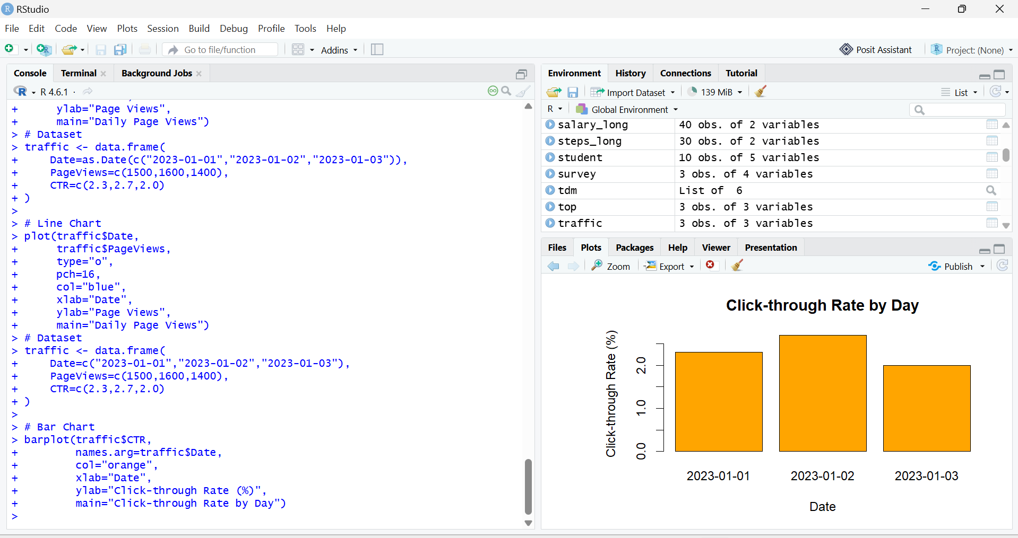

Q3. Table
traffic <- data.frame(
Date=c("2023-01-01","2023-01-02","2023-01-03"),
PageViews=c(1500,1600,1400),
CTR=c("2.3%","2.7%","2.0%")
)
Traffic
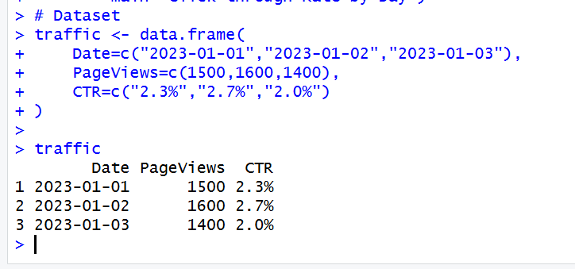

SET 13 – Geographic Data Analysis
Q1. Map Chart
geo <- data.frame(
City = c("City A","City B","City C"),
Latitude = c(13.08,12.97,17.38),
Longitude = c(80.27,77.59,78.48),
Population = c(500000,700000,600000),
AvgTemperature = c(75,68,80),
Elevation = c(1000,800,1200)
)
plot(geo$Longitude, geo$Latitude,
pch=19,
col="blue",
xlab="Longitude",
ylab="Latitude",
main="Geographic Distribution of Cities")
text(geo$Longitude, geo$Latitude,
labels=geo$City,
pos=3)
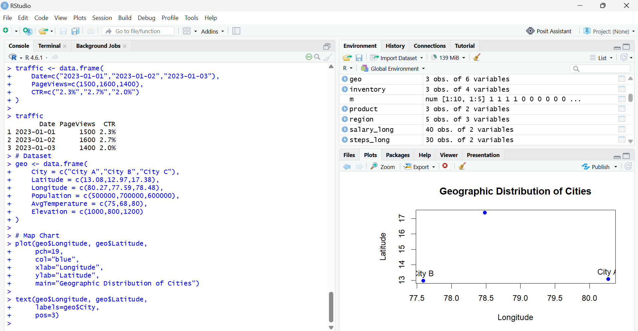

Q2. Scatter Plot
geo <- data.frame(
City = c("City A","City B","City C"),
Population = c(500000,700000,600000),
AvgTemperature = c(75,68,80),
Elevation = c(1000,800,1200)
)
plot(geo$AvgTemperature,
geo$Population,
pch=19,
col="red",
xlab="Average Temperature",
ylab="Population",
main="Temperature vs Population")
text(geo$AvgTemperature,
geo$Population,
labels=geo$City,
pos=3)
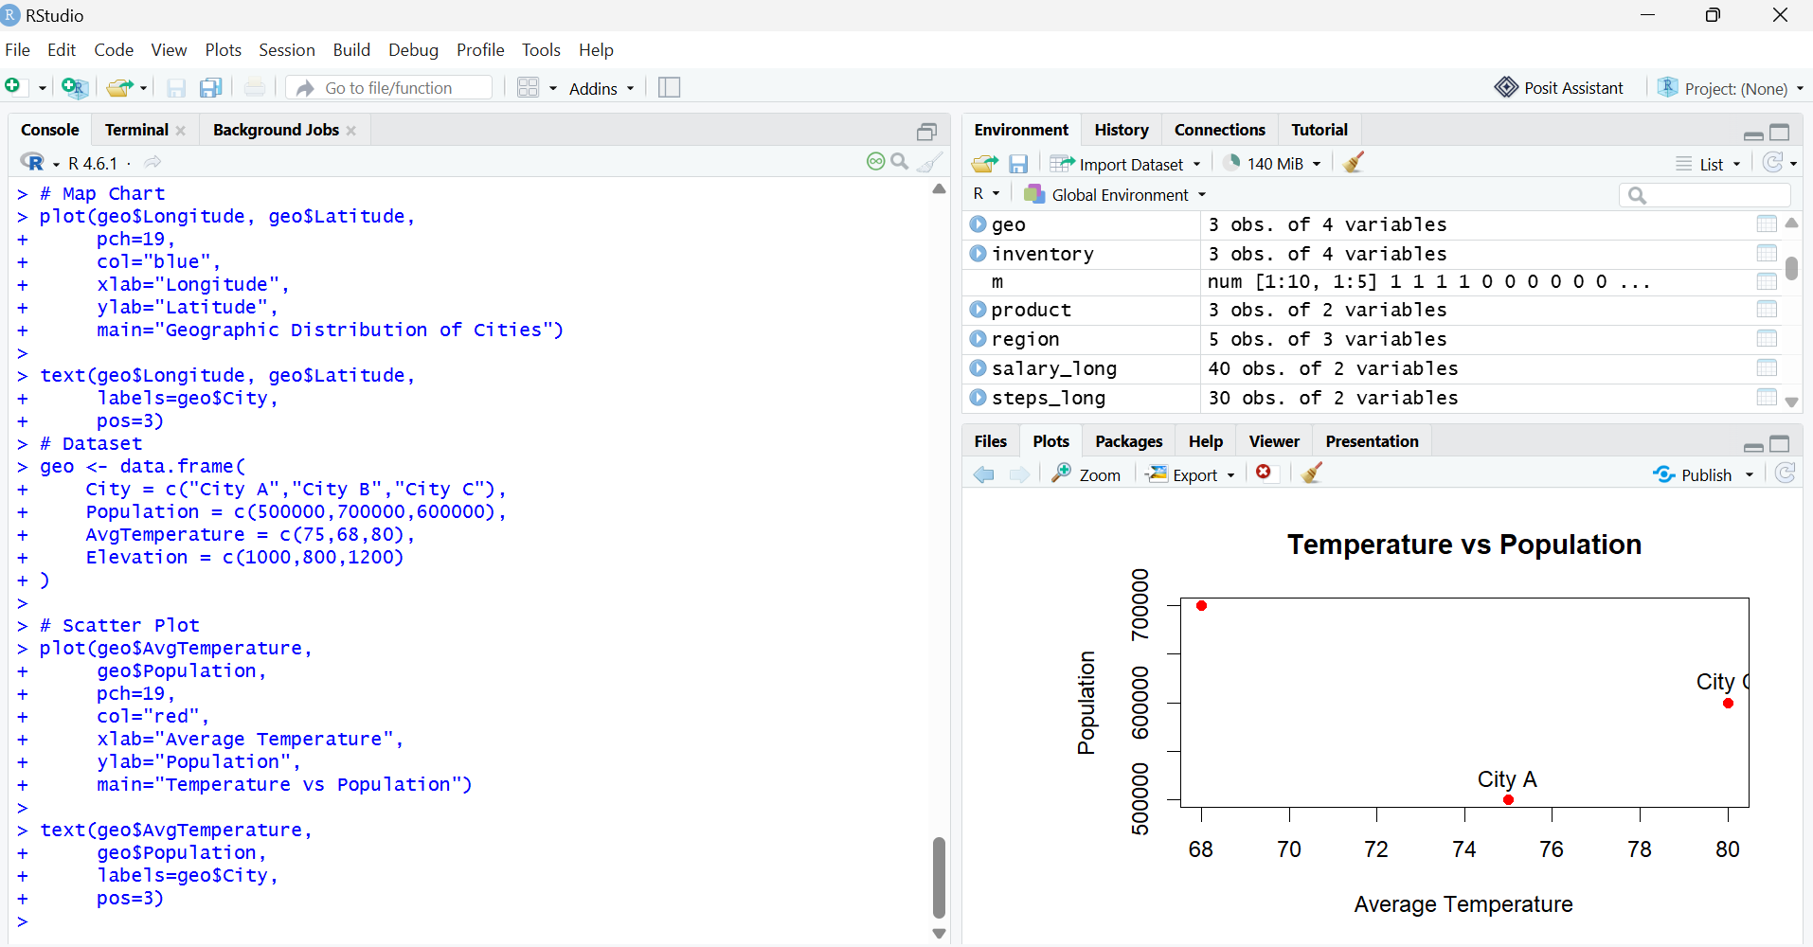

Q3. Table
geo <- data.frame(
City = c("City A","City B","City C"),
Population = c(500000,700000,600000),
AvgTemperature = c(75,68,80),
Elevation = c(1000,800,1200)
)
Geo
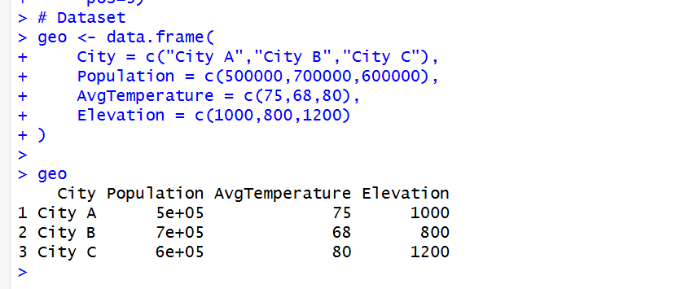

SET 14 – Survey Results Analysis
Q1. Stacked Bar Chart
survey <- data.frame(
Respondent = c(1,2,3),
Question1 = c("A","B","C"),
Question2 = c("B","A","D"),
Question3 = c("C","D","B")
)
q1 <- table(factor(survey$Question1, levels=c("A","B","C","D")))
barplot(rbind(q1),
beside=FALSE,
col="skyblue",
names.arg=names(q1),
xlab="Responses",
ylab="Count",
main="Distribution of Question 1 Responses")
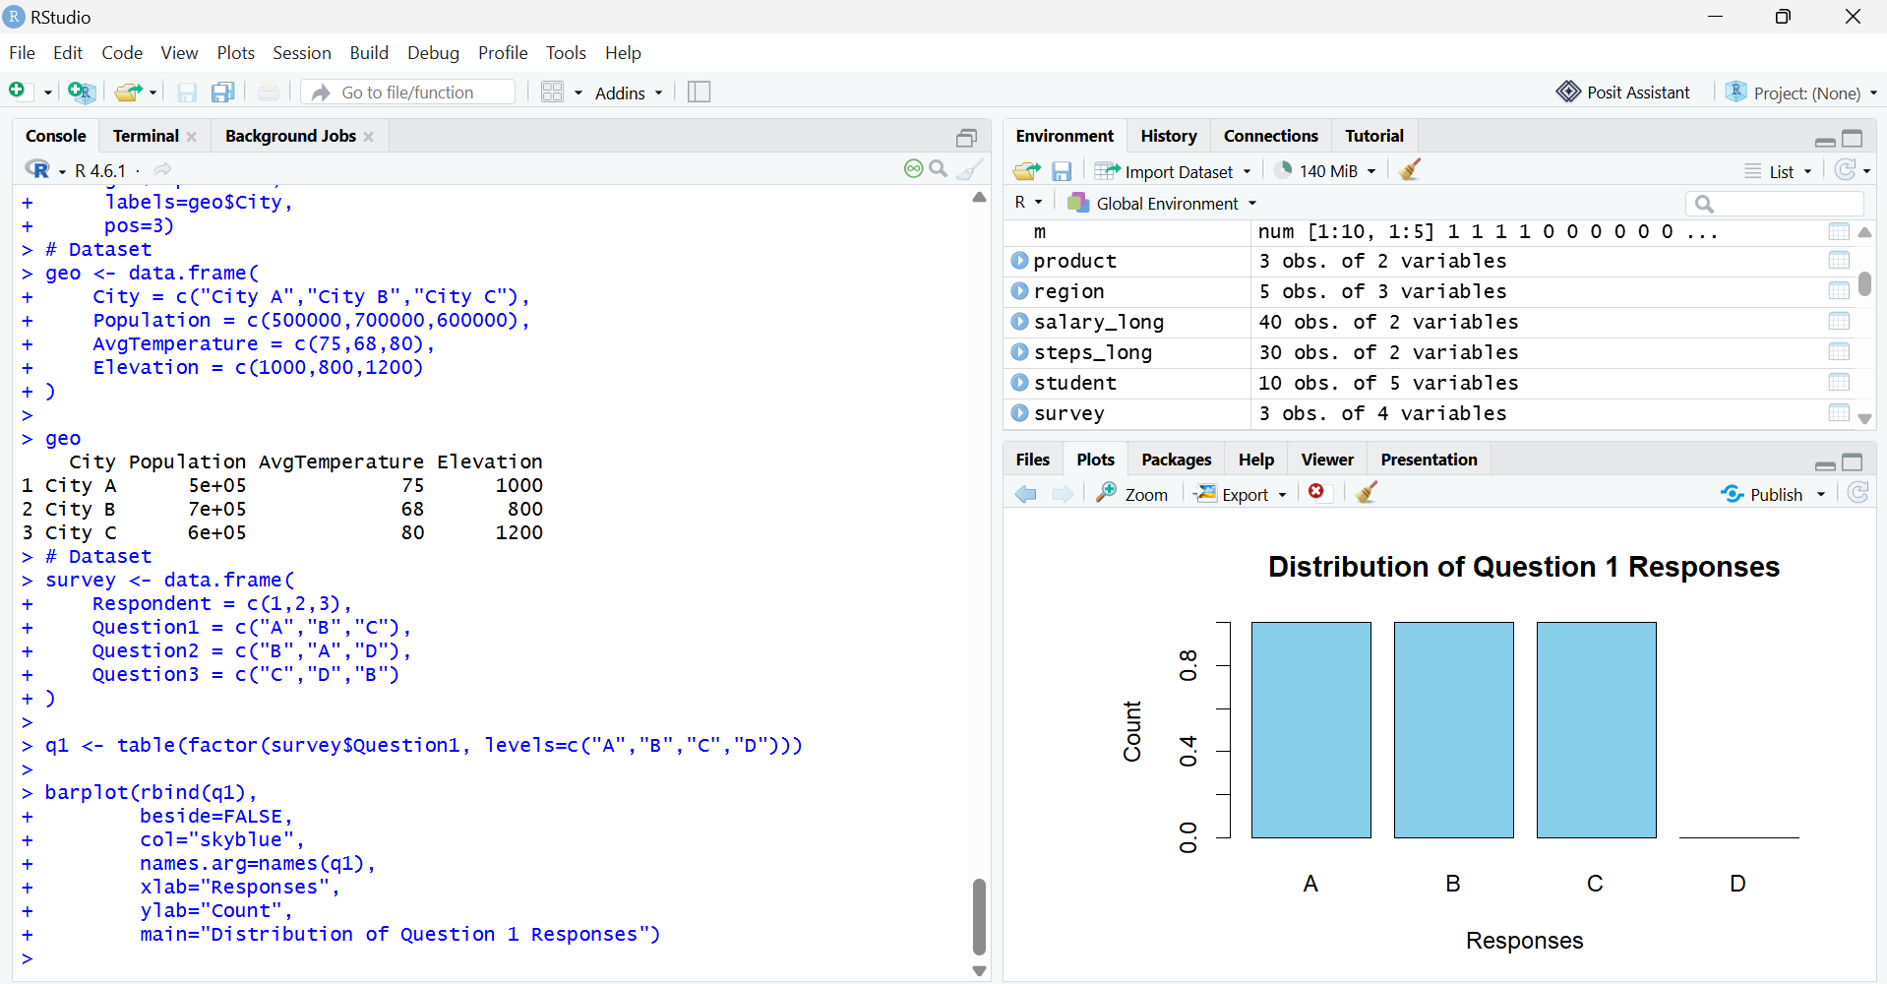

Q2. Radar Chart
survey <- data.frame(
Respondent = c(1,2,3),
Question1 = c("A","B","C"),
Question2 = c("B","A","D"),
Question3 = c("C","D","B")
)
responses <- table(factor(c(survey$Question1,
survey$Question2,
survey$Question3),
levels=c("A","B","C","D")))
plot(responses,
type="b",
pch=19,
col="blue",
xlab="Response",
ylab="Count",
main="Overall Pattern of Survey Responses")
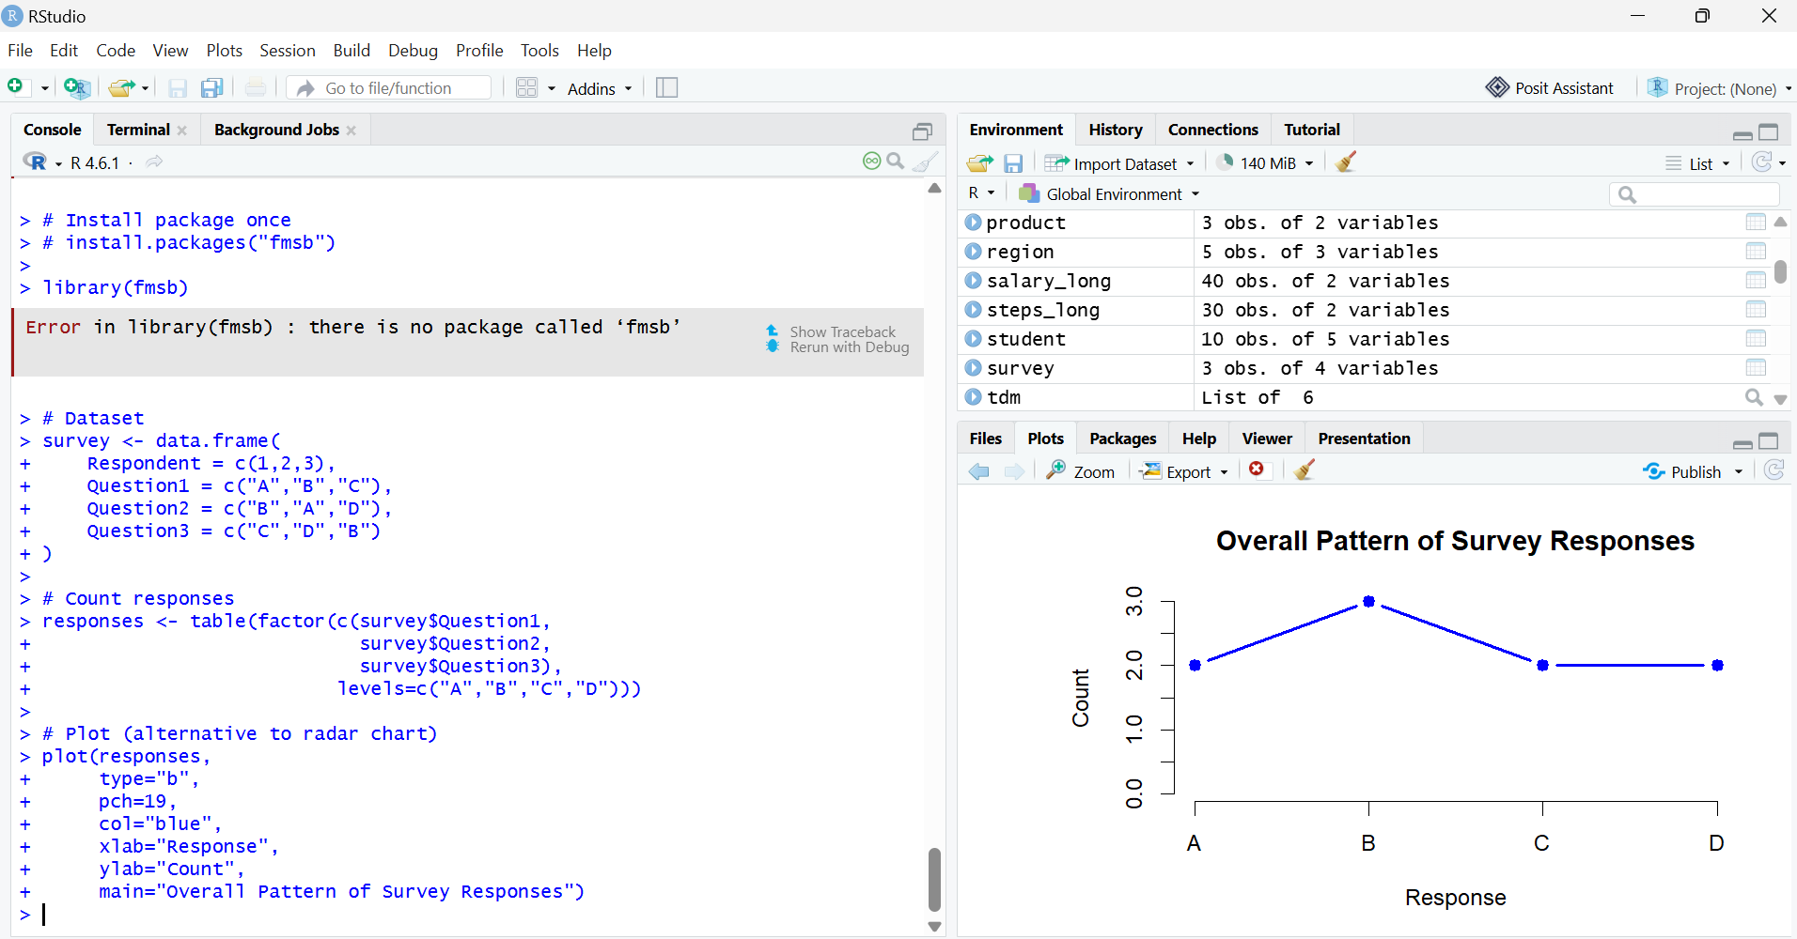

Q3. Table
survey <- data.frame(
Respondent = c(1,2,3),
Question1 = c("A","B","C"),
Question2 = c("B","A","D"),
Question3 = c("C","D","B")
)
Survey
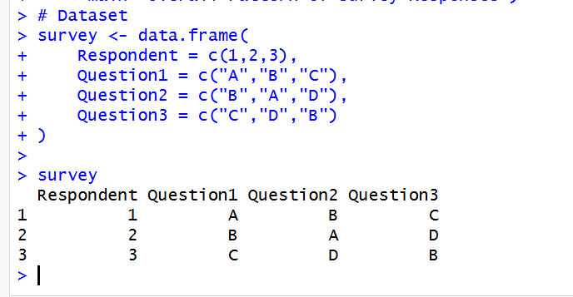

SET 15 – Survey Responses Analysis
Q17. Grouped Bar Chart
survey <- data.frame(
SurveyID = c(1,2,3),
Question1 = c("A","B","C"),
Question2 = c("B","A","D"),
Question3 = c("C","D","B")
)
q1 <- table(survey$Question1)
barplot(q1,
beside = TRUE,
col = c("red","green","blue"),
xlab = "Responses",
ylab = "Count",
main = "Distribution of Question 1 Responses")
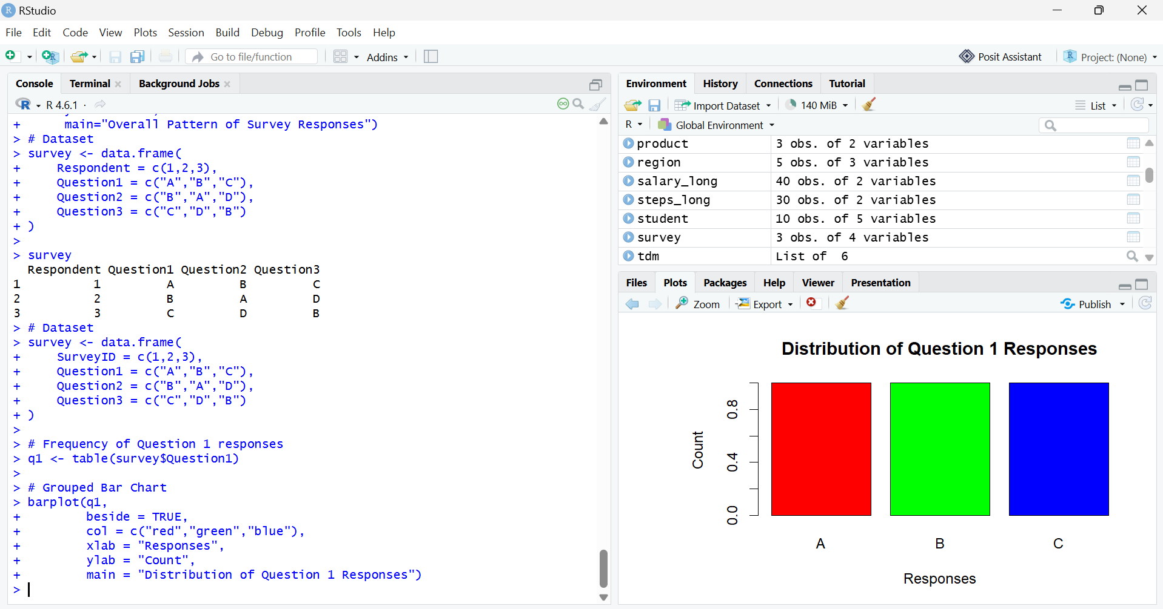

Q18. Stacked Bar Chart
survey <- data.frame(
SurveyID = c(1,2,3),
Question1 = c("A","B","C"),
Question2 = c("B","A","D"),
Question3 = c("C","D","B")
)
q1 <- table(factor(survey$Question1, levels=c("A","B","C","D")))
q2 <- table(factor(survey$Question2, levels=c("A","B","C","D")))
q3 <- table(factor(survey$Question3, levels=c("A","B","C","D")))
data <- rbind(q1,q2,q3)
barplot(data,
beside = FALSE,
col = c("red","green","blue"),
legend.text = c("Question 1","Question 2","Question 3"),
xlab = "Responses",
ylab = "Count",
main = "Overall Distribution of Survey Responses")
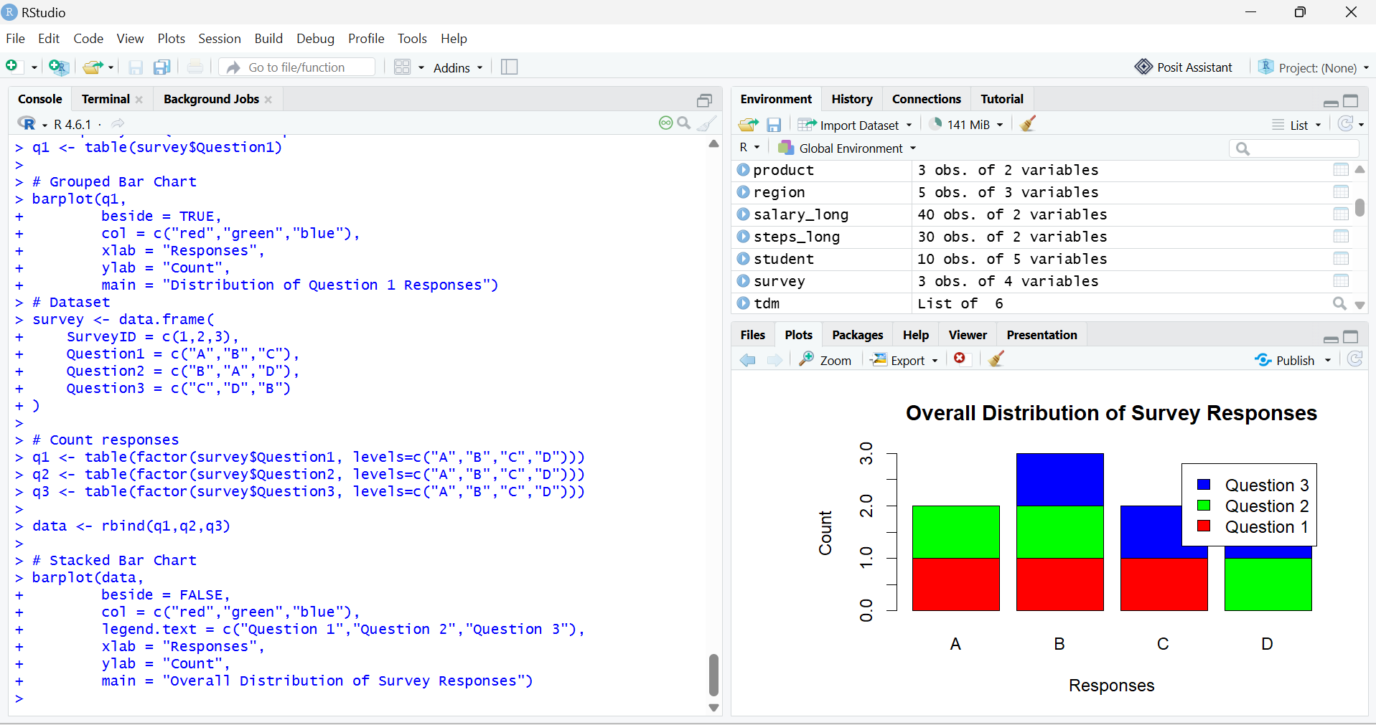

Q19. Table
survey <- data.frame(
SurveyID = c(1,2,3),
Question1 = c("A","B","C"),
Question2 = c("B","A","D"),
Question3 = c("C","D","B")
)
Survey
